Python For Beginners

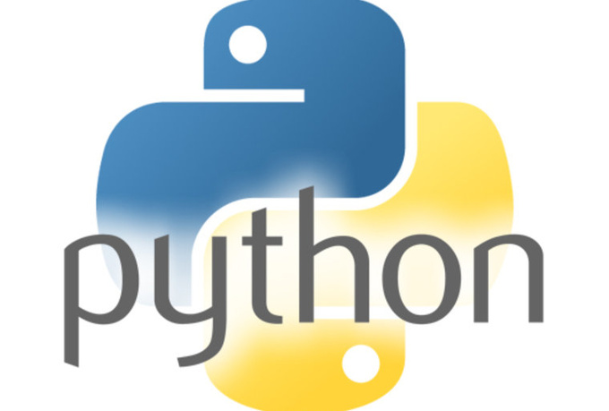

Source:Digital image. Intro to Programming in Python. N.p., n.d. Web.

Yongshan Tan

Caylah Peoples

**Table of Contents**

Introduction…………………………………………………………………………………………….. 3

Technical Definitions……………………………………………………………………………….. 4

Python (YT)………………………………………………………………………………..….. 4

Python Shell (YT)……………………………………………………………………………. 4

Python Script (CP)………………………………………………………………………….. 5

Running (CP)………………………………………………………………………………..… 5

Descriptions…………………………………………………………………………………………….. 6

A Description of the Python Shell Interface (YT)……………………………… 6

File Tab (YT)……………………………………………………………………………………. 6

Edit Tab (CP)…………………………………………………………………………………… 9

How-To’s for Python Beginners……………………………………………………………….. 10

How to Download Python (YT)……………………………………………………….. 10

How to Run Code (CP)……………………………………………………………………. 16

How to Open Python Document from Folder (CP)…………………………. 18

About the Authors…………………………………………………………………………………… 20

Works consulted Page……………………………………………………………………………… 21

**Introduction**

Computer science has become increasingly popular as more types of technology is created. With many different programming languages, learning how to use a computer program can be difficult for beginners. Thankfully, Python helps to introduce computer programming to beginners with ease.

This manual covers how to download Python and to use basic techniques for opening and editing the code. The manual includes defined terms and descriptions related to Python’s interface. Because the instructions are the main focus in this manual, the definitions and the descriptions are not required to read. However, they provide knowledge on any technical terms used throughout the manual.

**Technical Definition**

**Python**

Python is a high-level programming language that is useful for Rapid Application Development. Python has high readability and it can accomplish the same task in fewer lines of code than other programming languages like C/C++ or Java. Python can be installed on many operating systems, such as Windows, Mac OS X, or Linux, and it is free.

For Python beginners, the most used function on Python is the module. The module is a simple source file in Python which contains definitions (used in the script) and statements with the “.py” extension. See the module example in *Figure 1*.

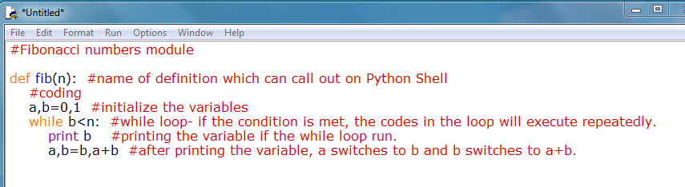

*Figure 1*

**Python Shell**

The Python shell is an interactive window that pops up when users open the program through IDLE (integrated development environment). The shell can evaluate statements and expressions that users type in. Moreover, the shell allows the users to run functions, import modules, and name variables for later usage inside of the shell.

**Technical Definition (Cont.)**

**Python Script**

A script is an edit window that is used to create a complete code. Unlike the shell, which immediately implements the code, the script allows users to save and edit code outside of the shell. The script acts as the input value, in which the users plug in the functions in order to execute them in the shell.

The script also allows users to define an unlimited amount of functions without losing any data. Some code that contains colors in their text indicates the functions that Python uses. For example, comments are shown in red, the print function is in purple, and the definition is in blue (*see in Figure 1*). In order to execute the code into the shell, the script needs to run the code into the shell.

**Running**

Running is the process that allows Python to execute and to implement a code into the shell. When a script runs, the shell restarts and allows the users to execute the code made outside of it. The shell also runs imported modules, or scripts already created for Python. Running an imported module helps users to focus on implementing code from multiple modules without the need to edit them.

**Descriptions**

**A Description of the Python Shell Interface**

The Python Shell is an interactive shell that can effectively evaluate the statements and the expressions that users type in. The shell allows users to run functions, import modules, and name variables for later usage in the shell. Python Shell interface is the first window that pops up when clicking on IDLE (integrated development environment) of Python to open the program on computer.

Python Shell has seven tabs on the top bar which are File, Edit, Shell, Debug, Options, Window, and Help. The focus points on this description are File tab and Edit tab.

**Note:** All the shortcuts shown below are using for Window only.

**File Tab**

|  |  |
| --- | --- |
| **Open the New File (shortcut—Ctrl+N):** Users can open the script by clicking on “New File”. In the Python script, the users can use the module and package to write their codes. They also can write their own defined functions, in which they can call it back to use in the Shell for later.  *(See item1 in Figure 1 for Open the New File.)* |  |
| **Open the Existing File (shortcut—Ctrl+O):** Users can open the existing files by clicking on “Open…”. Then users will see the new pop-up window that contains all the files that it had in the computer. They can go to the location of the file that they need, and click on the file to open.  *(See item2 in Figure 1 for Open the Existing File)* | *Figure 1*  *Figure 1* |
| **Descriptions (Cont.)** | |
| **Open the Recent File:** Users can open recently closed files by viewing on “Recent File”. The list of recently closed files are ordered from most to less recent by number 1 to 9, then follow by 0 and A.  *(See item3 in Figure 2 for Open the Recent File.)* |  |
| **Save the File (shortcut—Ctrl+S):** Users can save the file on Python Shell by clicking on “Save”. Then users will see the new pop up window where they can chose the location to save the files. The coding in Python Shell will save as script.  *(See item4 in Figure 2 for Save the File.)* | *Figure 2* |
| **File Save As (shortcut—Ctrl+Shift+S):** Users can save the saved file again by clicking on “Save As…”. When users can’t find the file’s location that they saved before, they can use “Save As…” to save the file again in a new location where they can remember.  (*See item5 in Figure 2 for File Save As.)* |  |

|  |  |
| --- | --- |
| **Descriptions (Cont.)**  **Conclusion**  Python Shell file tab is a useful tool to help users quickly and easily to use the Python for coding. Python Shell file tab contains the features that users would like to use frequently, such as New File, Open…, Recent Files, Save, and Save As…. | |
| **Descriptions (Cont.)** | |
| **Edit Tab**  **Undoing (CTRL+Z) and Redoing (CTRL+Shift+Z) Text**: By undoing unwanted text, the user can delete mistakes from the shell. The users also have the option to redo those mistakes, which prints the previously typed text again. These options help the users to quickly type and delete text without having to retype it again.  *(See item6 in Figure 3 for Undo and item7 in Figure 3 for Redo)* | **Lable10** |
| **Cutting (CTRL+X), Copying (CTRL+C), and Pasting (CTRL+Z) Text**: Similar to undoing and redoing text, the users have the option to copy and paste any amount of text into their shell. The “Cut” and “Copy” options can copy a selected text (unlike copy, cut deletes the text after copying it). Afterwards, the user can paste, or display, the selected text into the shell.  (*See Figure 3 item8 for Cut*  *Item9 for Copy*  *Item10 for Paste)* | *Figure 3* |

**Conclusion**

The Python shell in interface gives the users the ability to run function, import modules, and name variables. Through the Edit Tab, the user can adjust their code by deleting and reusing it. These options benefit the user by providing quicker ways to edit code through the use of shortcuts.

**“How-To’s” for Python Beginners**

**How to Download the Python**

This instruction will present detailed steps for Python beginners to install the Python. After users read this instruction, users will get a better idea on where to download the Python, how to download the right version of the Python that users need, and where to open the Python Shell. Moreover, it is better to use this instruction while users are with the computer.

|  |  |
| --- | --- |
| Open <https://www.python.org/>  In Browser *(see Figure 1)*  **Note**: The Browser that is show in *Figure 1* is Google Chrome. | C:\Users\Iris\Desktop\1.png  *Figure 1* |
| Move the mouse to Download *(see Figure 2)*  Then users will see a list. | C:\Users\Iris\Desktop\2.png  *Figure 2* |
| **“How-To’s” for Python Beginners (Cont.)** | |
| **Note:** If users are a Mac user, skip ‘Windows Users’ section and go to ‘Mac OS X users’ section.  **Note for both Window User and Mac OS X User**: Usually we use Python 3.5.0 instead of Python 2.7.10 because it is easier to use for coding.  **Windows Users:**  (except Window 8 &10):  Click on Python 3.5.0 to start download  *(see Figure 3.1)* | *Figure 3.1-Windows User* |
| **“How-To’s” for Python Beginners (Cont.)** | |
| (continues on Step 3)  **Mac OS X Users:**   1. Click on Mac OS x   *(see Figure 3.2)*   1. **Mac OS X 64 bit user:**   Click on Download Mac OS X 64-bit/32-bit installer  *(see Figure 3.3-1st bullet point)*  ***OR***  **Mac OS X 32 bit user:**  Click on Download Mac OS X 32-bit i386/PPC installer  *(see Figure 3.3-2nd bullet point)* | *Figure 3.2-Mac OS X User*    *Figure 3.3-Mac OS X User* |
| Click on the Python 3.5.0 downloaded file  *(see Figure 4)*  Then users will see a new pop up window. *(see Figure 5)* | *Figure 4* |
| **“How-To’s” for Python Beginners (Cont.)** | |
| Click on Run  *(see Figure 5 )* | C:\Users\Iris\Documents\Tencent Files\573207216\Image\C2C\D9E4RP[5}67Y0H$~G2FS{3W.png  *Figure 5* |
| Wait for the Setup Progress bar full with green  *(see Figure 7 )* | C:\Users\Iris\Documents\Tencent Files\573207216\Image\C2C\76@BC[4N[N6G]%T%%MA$@~1.png  *Figure 7* |
| Click on Close to finish the download of Python  *(see Figure 8 )* | C:\Users\Iris\Documents\Tencent Files\573207216\Image\C2C\FE6Q2P94_$6{O{$B1OHF(0U.png  *Figure 8* |
| **“How-To’s” for Python Beginners (Cont.)** | |
| **Note:** By using the Python program to do the coding, users should do the following steps, step 8 to step 10.  Click on Start  *(see Figure 9—red box )*      Type Python on Search Bar  *(see Figure 9—purple box )*  Click on IDLE(Python 3.5 32-bit)  *(see Figure 9—orange box )*  Then users will see the Python 3.5.0 Shell window pop up.  *(see Figure 10 )* | C:\Users\Iris\Documents\Tencent Files\573207216\Image\C2C\NWA~PQ6IHF_8[TO%US7(`2P.jpg  *Figure 9*  C:\Users\Iris\AppData\Roaming\Tencent\Users\573207216\QQ\WinTemp\RichOle\0[LA)}WEP88@KO@U_U8Y4R4.png  *Figure 10* |

**“How-To’s” for Python Beginners (Cont.)**

**Conclusion:**

This introduction shows to users the easy and fast way to download and use the right version of Python. Step 1 to Step 7 show how to download the Python from Python’s official website. After users finish the downloading steps, the Step 7 to Step 10 show how to open the Python program in users’ computer.

**“How-To’s” for Python Beginners (Cont.)**

**How to Run Code from a Python Document**

People who are new to Python may want to see their code work, but may not know how to do so. These steps will help the user to run their code while using some shortcuts to make the process easier.

|  |  |
| --- | --- |
| Press Ctrl+N to open a document. A blank Python document should pop up  (*See Figure 1*). | C:\Users\Iris\AppData\Roaming\Tencent\Users\573207216\QQ\WinTemp\RichOle\0CF[4]I%%C$5_2CXLYYTT06.png  *Figure 1* |
| Press F5 to run the document with the created code. A pop-up box (See Figure 2) should give users the option to save the file. | part1.png  *Figure 2* |
| **“How-To’s” for Python Beginners (Cont.)** | |
| Click OK on the pop-up box  The users will see the new pop-up window show as *(Figure3 )*    Name the document ending with ‘.py’  (*See Figure 3)*.  This will save the document as the correct file type. | part2.png*Figure 3* |
| RESTART shown in the Shell after users run the code.  (*See Figure 4*)  Then, the code users write on Script should be called into the Shell. | part3.png  *Figure 4* |

**“How-To’s” for Python Beginners (Cont.)**

**How to Open a Python Document from a Folder**

Sometimes the users want to edit their document file, but they are unable to when they try to open it. These steps will help the users to understand how to open their document properly.

|  |  |
| --- | --- |
| Go to the folder to look for the Python document  (*see Figure 5*). | stepa1.png  *Figure 5* |
| Right-click onto the file to open the option bar when users find the document  (*See Figure 6*). | stepa4.png  *Figure 6* |
| **“How-To’s” for Python Beginners (Cont.)** | |
| Click on Edit with IDLE  (*See Figure 7*)  .  Then, users will open the Python document as Script.  *(see Figure 8)*  At this time, users can access and edit on the document. | step3.png  *Figure 7*  step2-2.png  *Figure 8* |

**About the Authors**

Caylah Peoples and Yongshan Tan are Junior DePaul students majoring in Computer Sciences.

Caylah gains at least one year of experience using Python and HTML.

Yongshan is practicing how to use Python, but also has experience using other programming languages, such as C++.

**Works Consulted Page**

**Yongshan Tan:**

* https://en.wikipedia.org/wiki/Python\_(programming\_language)
* https://www.python.org/doc/essays/blurb/
* https://wiki.python.org/moin/BeginnersGuide/Overview
* http://www.tutorialspoint.com/python/python\_overview.htm
* https://docs.python.org/2/tutorial/modules.html#packages
* http://www.learnpython.org/en/Modules\_and\_Packages

**Caylah Peoples**

* http://www.curiousefficiency.org.posts/2011/03/what-is-python-script.html
* http://searchenterpriselinux.techtarget.com/definition/script
* http://pythoncentral.io/execute-python-script-file-shell